|  |  |
| --- | --- |
| Course Name | ITD 2313 – Script Programming |
| Instructor | Mark Pranger |
| Student Name | Josh Jones |
| Due date | May 5 |
| Grade | <grade earned here> |
| Grading Comments | <instructor comments here> |

Install Python:

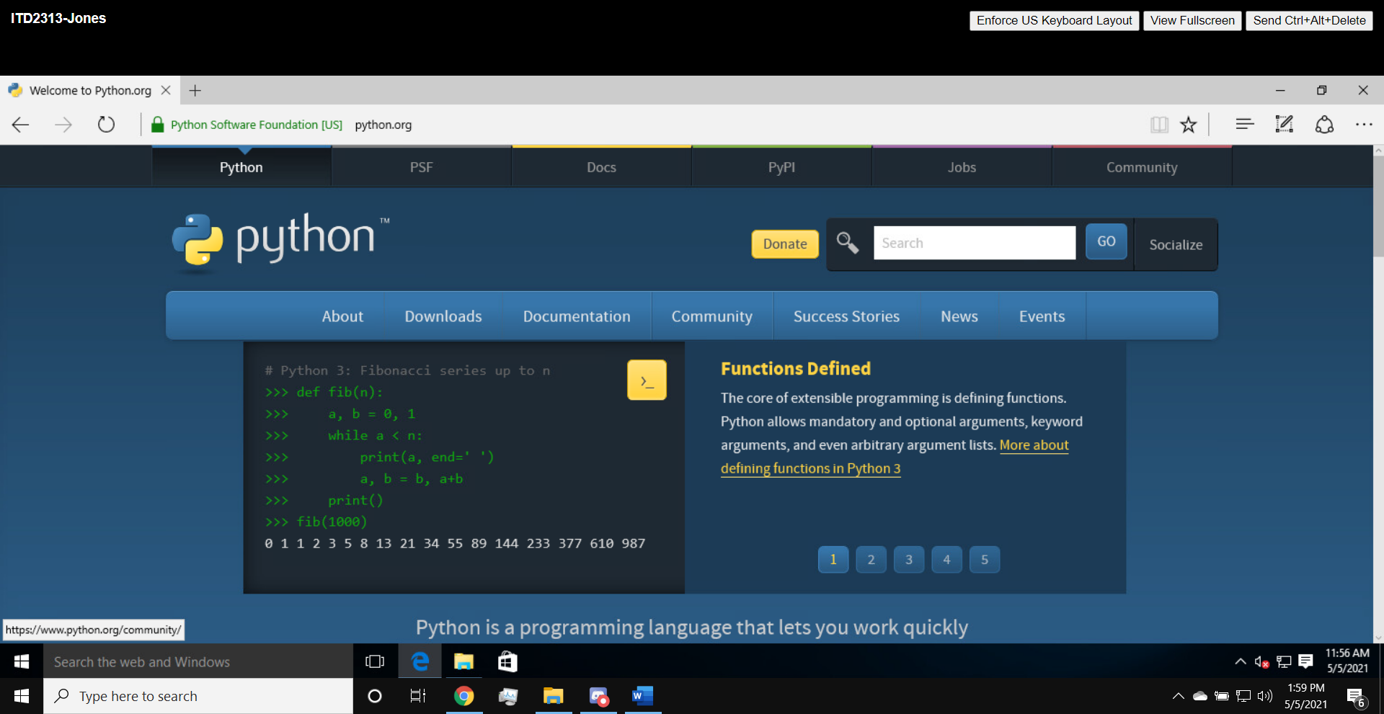

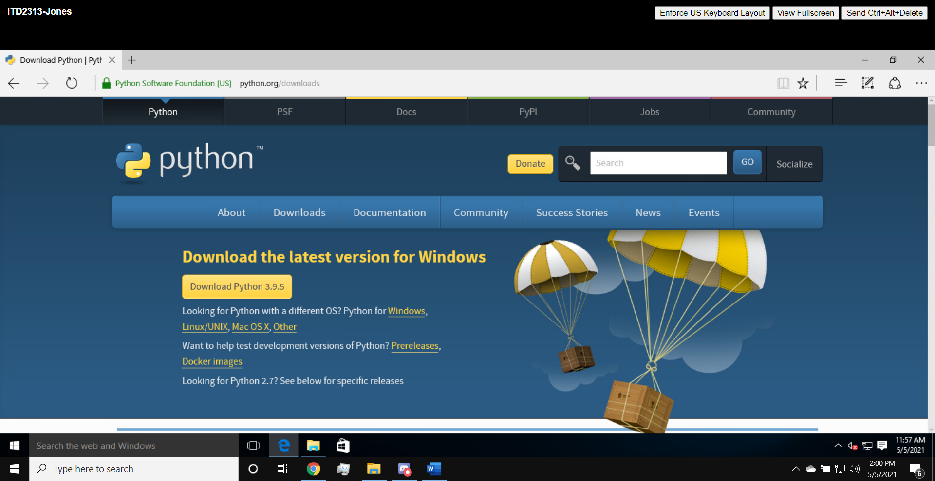

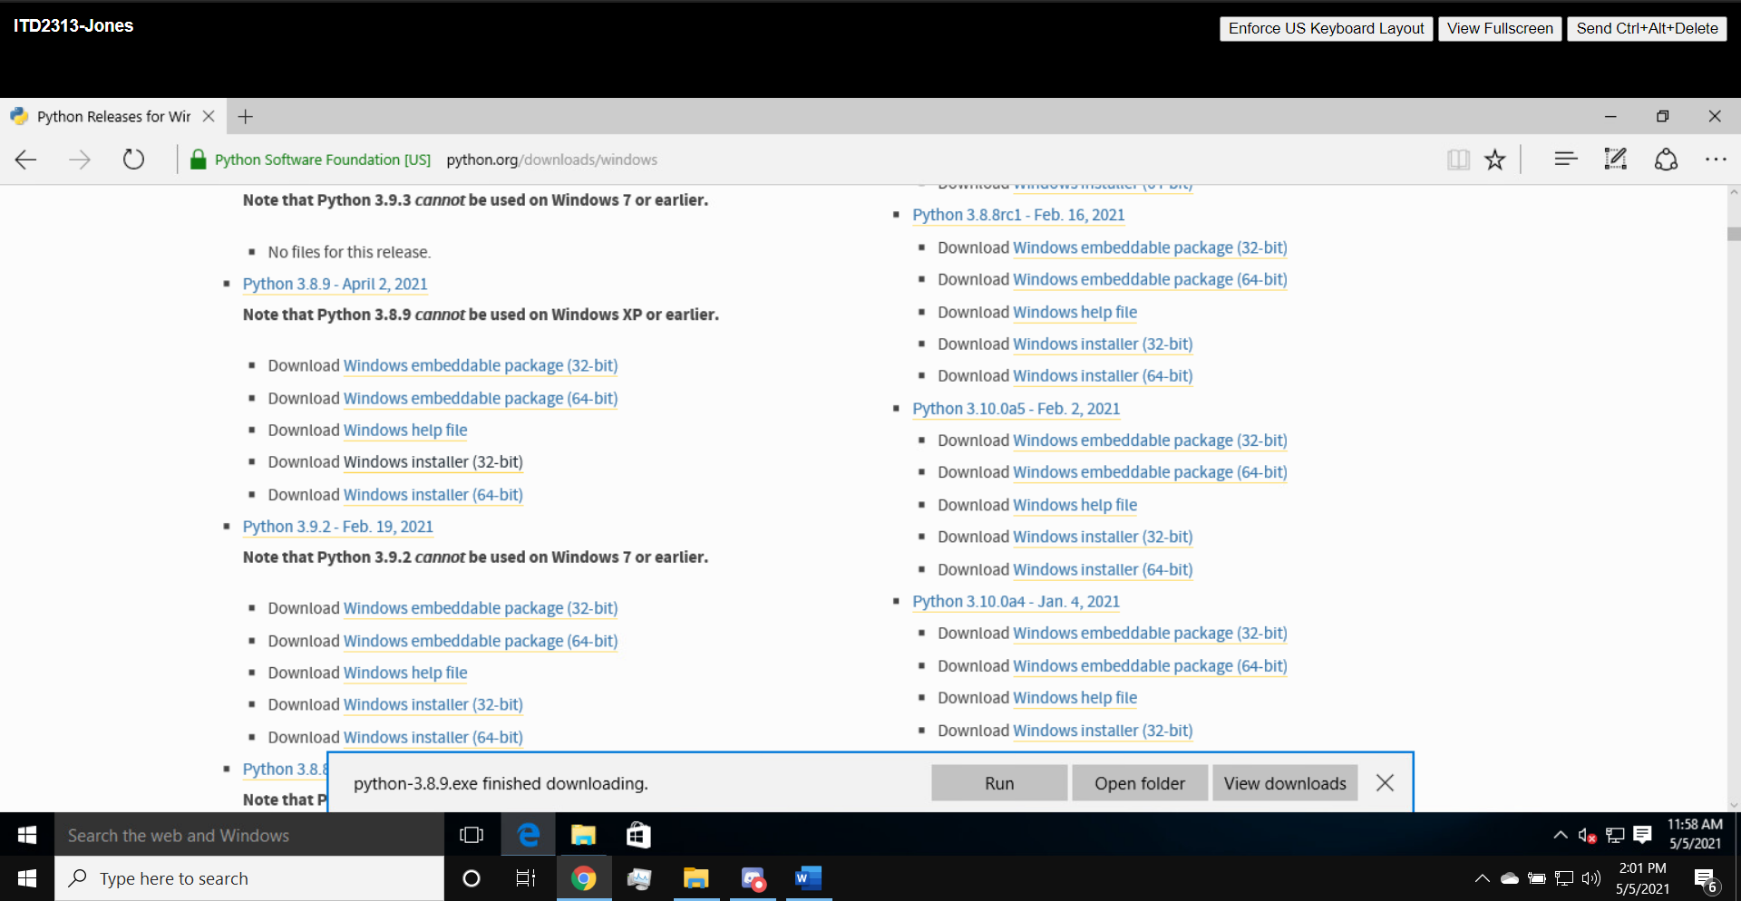

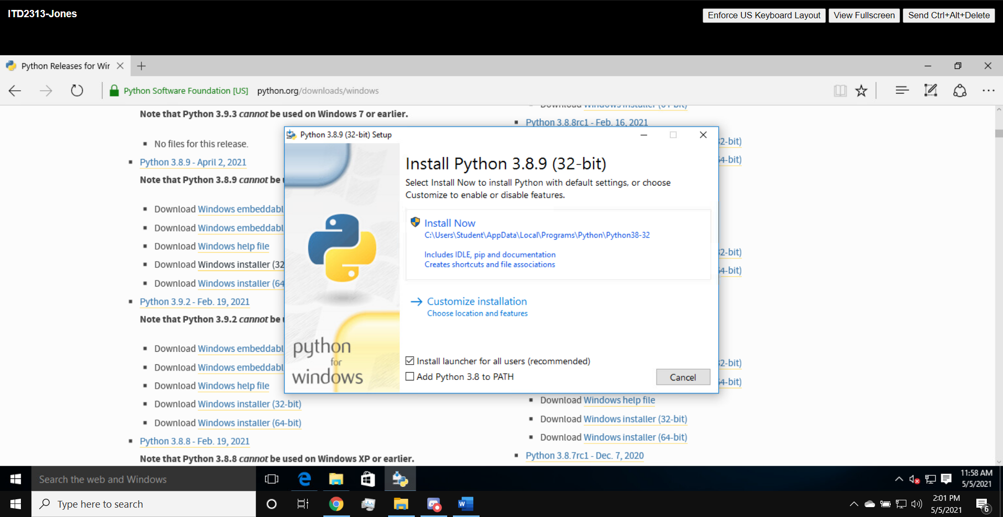

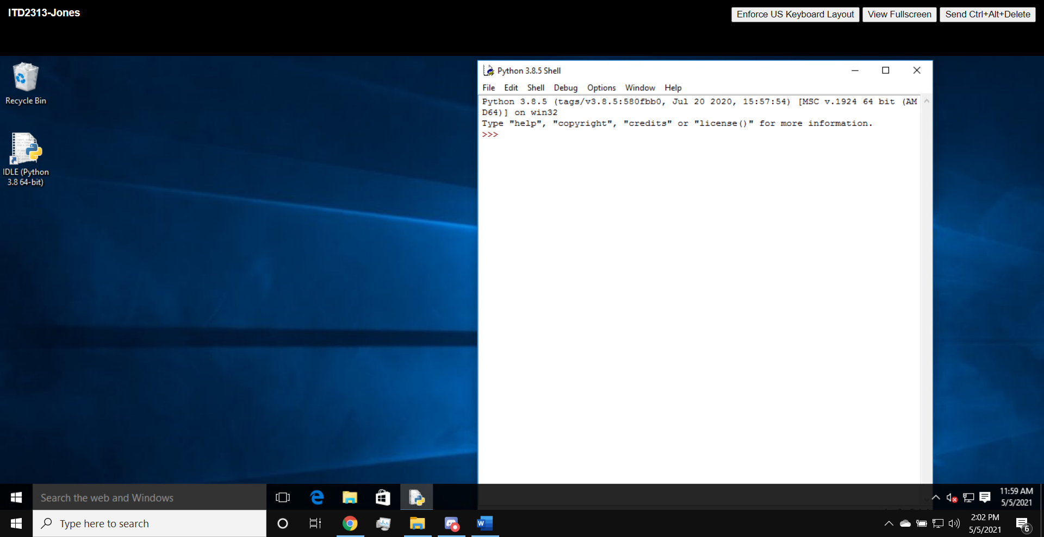

Running Code in the interactive shell:

Page 23:

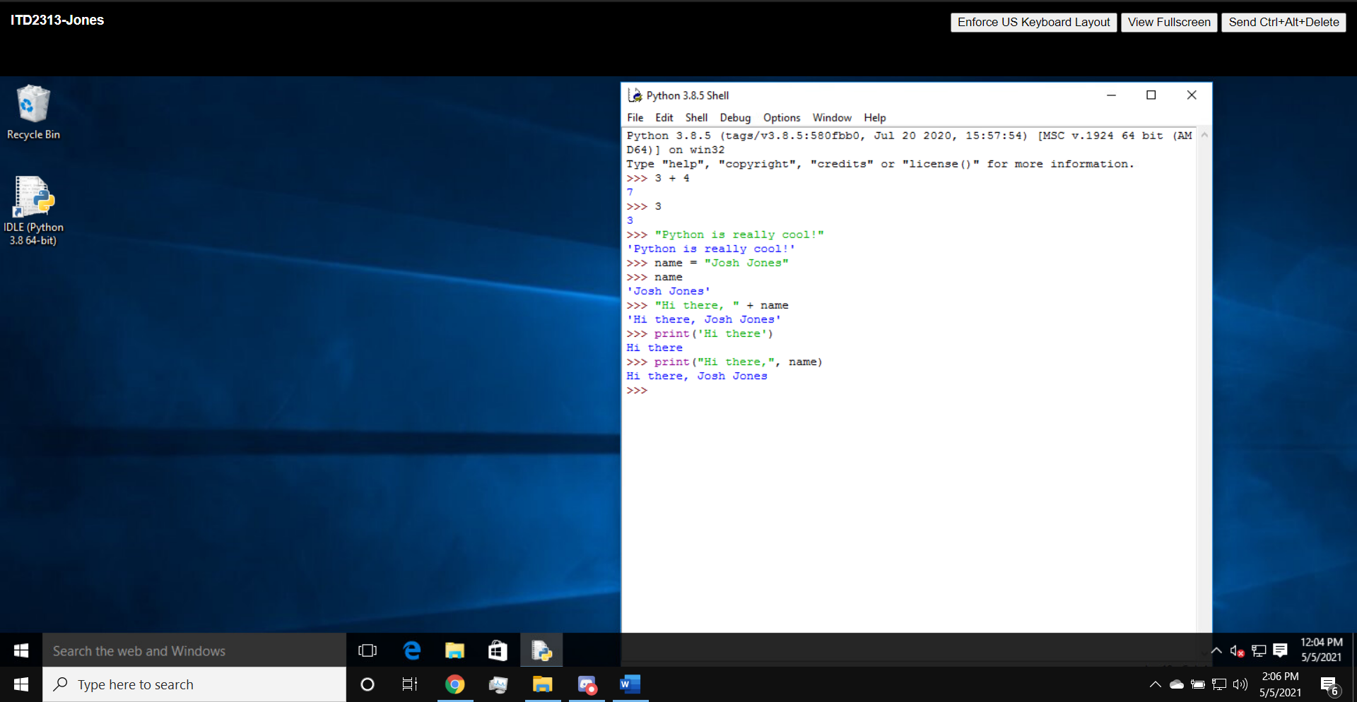

Input, Processing, Output:

Page 25:

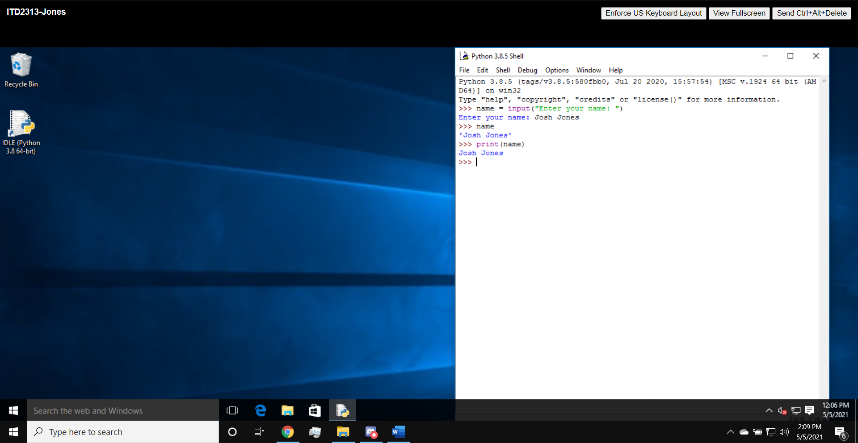

Page 26:

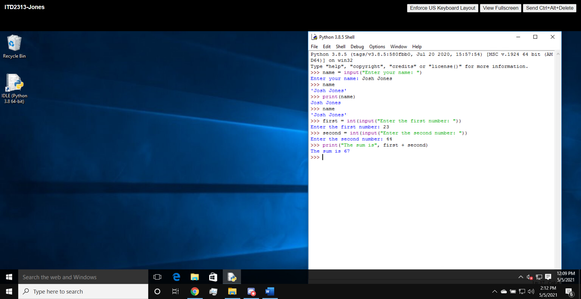

Detecting and Correcting Syntax Errors:

Page 29:

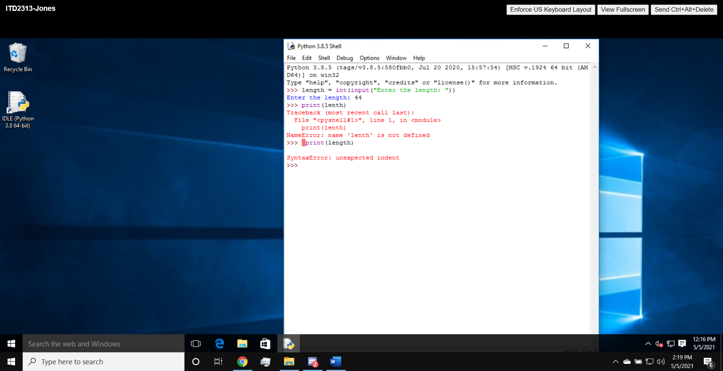

Page 30:

